**Anket Vilas Patil TY-IT-63**

**Experiment No. 4**

**Aim** : To study and demonstrate Ultrasonic Sensor usage.

**Objective** : 1. To understand ultrasonic sensors.

2. To use sensors for real time applications.

**Outcome** : Able to use ultrasonic sensors with Arduino IDE.

**Theory** :

An ultrasonic sensor is an electronic device that measures the distance of a target object by emitting ultrasonic sound waves, and converts the reflected sound into an electrical signal. Ultrasonic waves travel faster than the speed of audible sound (i.e. the sound that humans can hear). Ultrasonic sensors have two main components: the transmitter (which emits the sound using piezoelectric crystals) and the receiver (which encounters the sound after it has travelled to and from the target).

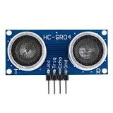

Ultrasonic sensors are a non-contacting way of monitoring and measuring position and displacement. They emit sound waves to do this. The sound waves are reflected to the sensor and based on what signals are received the ultrasonic sensor can give accurate measurements on proximity detection and measurement. They are very useful for a variety of applications. Ultrasonic sensors can detect any object irrespective of its size, colour, material or reflectivity.Ultrasonic sensors have many uses and can be found in a wide range of industries. They are robust sensors which means they have a long life expectancy.

There are two main types of Ultrasonic Sensors these are :

**Ranging Measurement Ultrasonic Sensors** - this type of ultrasonic sensor measures the exact distance or displacement of an object which is moving to and from the ultrasonic sensor itself using intermittent sound waves.

**Proximity Detection Ultrasonic Sensors** - this type of ultrasonic sensor monitors a specific area and will alert the user when an object enters that area of detection. Ultrasonic sensors are chosen for this application over other types of sensors because an ultrasonic sensor can detect an object irrespective of its size, material or reflectivity whereas other sensors cannot.

Within these types, there are different categories of ultrasonic sensors, these include;

* Close range ultrasonic sensors
* Intrinsically safe ultrasonic sensors
* High Accuracy ultrasonic sensors
* Self-contained ultrasonic sensors

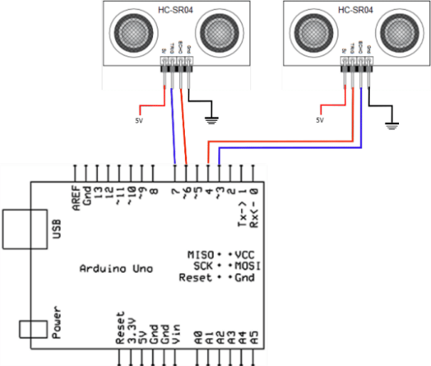

**Conclusion :** Thus, we learnt that an ultrasonic sensor is an electronic device that measures the distance of a target object by emitting ultrasonic sound waves, and converts the reflecting sound into an electrical signal.

**Circuit Diagram :**

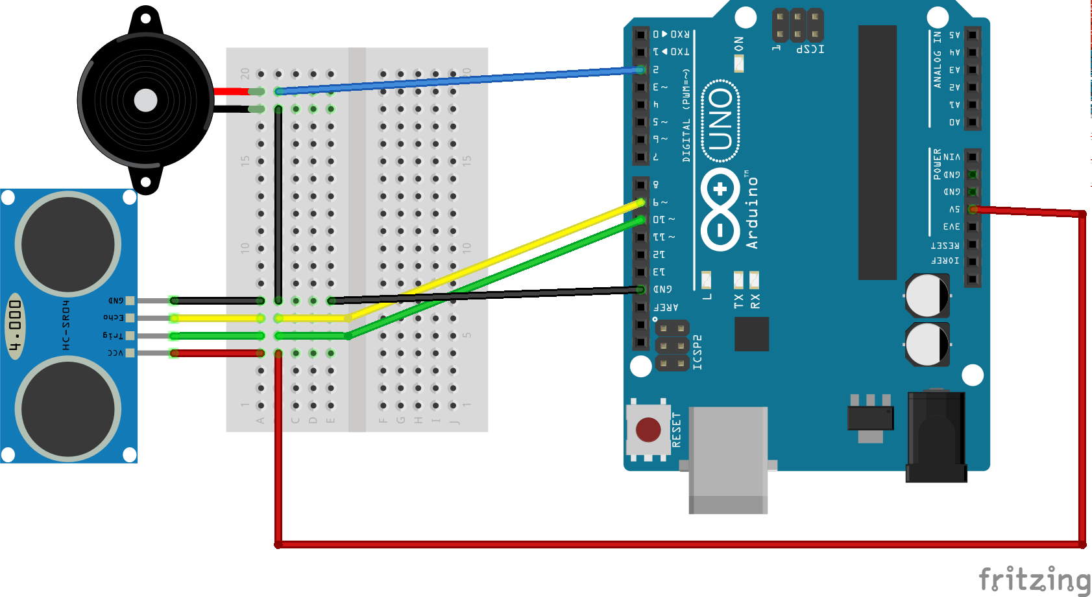

**Code :**

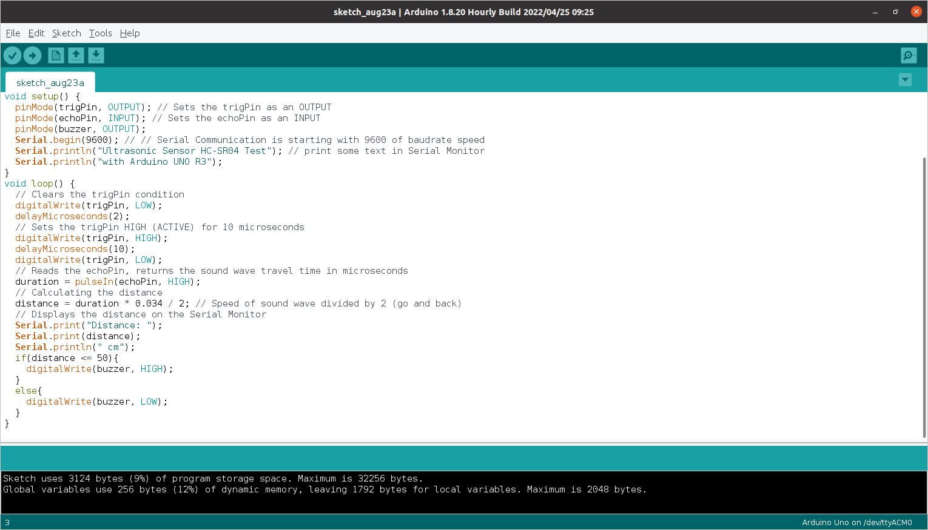



**Output :**

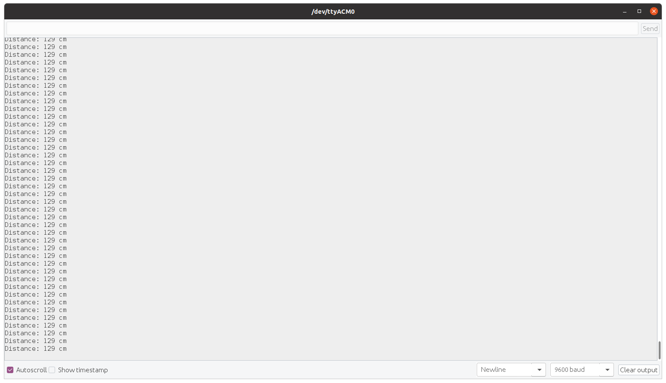

**Connections :**

